Step-by-Step

Practical Side of Marriage Prep for Priests & Deacons

Diocese of Biloxi, 6 May 2020
- Step #1: The Engaged Couple Contacts the Priest/Deacon by phone to set up their first meeting. This call needs to take place at least 6 months prior to the anticipated wedding date. During your conversation let the couple know that when they meet with you, face to face, they will be doing 3 things:
  - Reviewing the Couple Guide. So you will need to send this to them as soon as you hang up the phone! The “Couple Guide” summarizes what will be happening during the Marriage Preparation Process. (the Couple Guide is an appendix to the Marriage Policy or at https://www.biloxidiocese.org/couples-guide ).
  - Conducting a Prenuptial Investigation
  - And taking the FOCCUS Marital Inventory Assessment (It takes approximately 1 hour to administer)
- FIRST Meeting: Talk with the couple and get to know them. Find out if there are previous marriages and if so is/was an annulment process needed. Then:
  - Ask them if they had any questions about the “Couple Guide.”
  - Give them a “Roadmap” of the overall steps in marriage preparation. A PDF version is on the diocesan web site at: https://d2y1pz2y630308.cloudfront.net/2647/documents/2020/3/Marriage%20Prep%20Flowchart.pdf It is also on pg 3 of the Training Guide.
  - Do the Prenuptial Investigation with each privately and then have them sign their investigations. This establishes their “freedom to marry.”
  - Next sign them up to take the FOCCUS Assessment. Do this at your office. They can take the assessment either on-line in the parish office or at their homes. (https://www.foccusinc.com) The cost is $20 to take the assessment for a couple. They can pay online or the parish can pay online. Note: Your parish will need at least one certified FOCCUS Facilitator. This is done when parish signs up for FOCCUS. Every parish is responsible for registering with FOCCUS Inc. and most are already.
  - Finally discuss Natural Family Planning (NFP) with your couple.
    - Discuss the 3 NFP methods: Creighton; Marquette; and Couple to Couple League (CCL). Show them the differences between the methods. {see page 5 of Training Guide or Go to Diocesan Web Site and read “NFP Options” with them https://www.biloxidiocese.org/nfp-options
    - For homework have them watch 2 videos (1 hour each) on NFP. Both are on the diocesan web site at: https://www.biloxidiocese.org/nfp-videos
      - Jason Evert on Natural Family Planning
      - An Overview of Basic Reproductive Biology and NFP with introduction by Bishop Kihneman III
  - If your parish requires a “Wedding Coordinator,” to make sure there is proper music, a wedding rehearsal, and other norms put in place, then give the engaged a list of your approved wedding coordinators and have them make the contact.
  - Set up a second meeting with the couple to discuss the results of the FOCCUS Assessment and the NFP Videos.

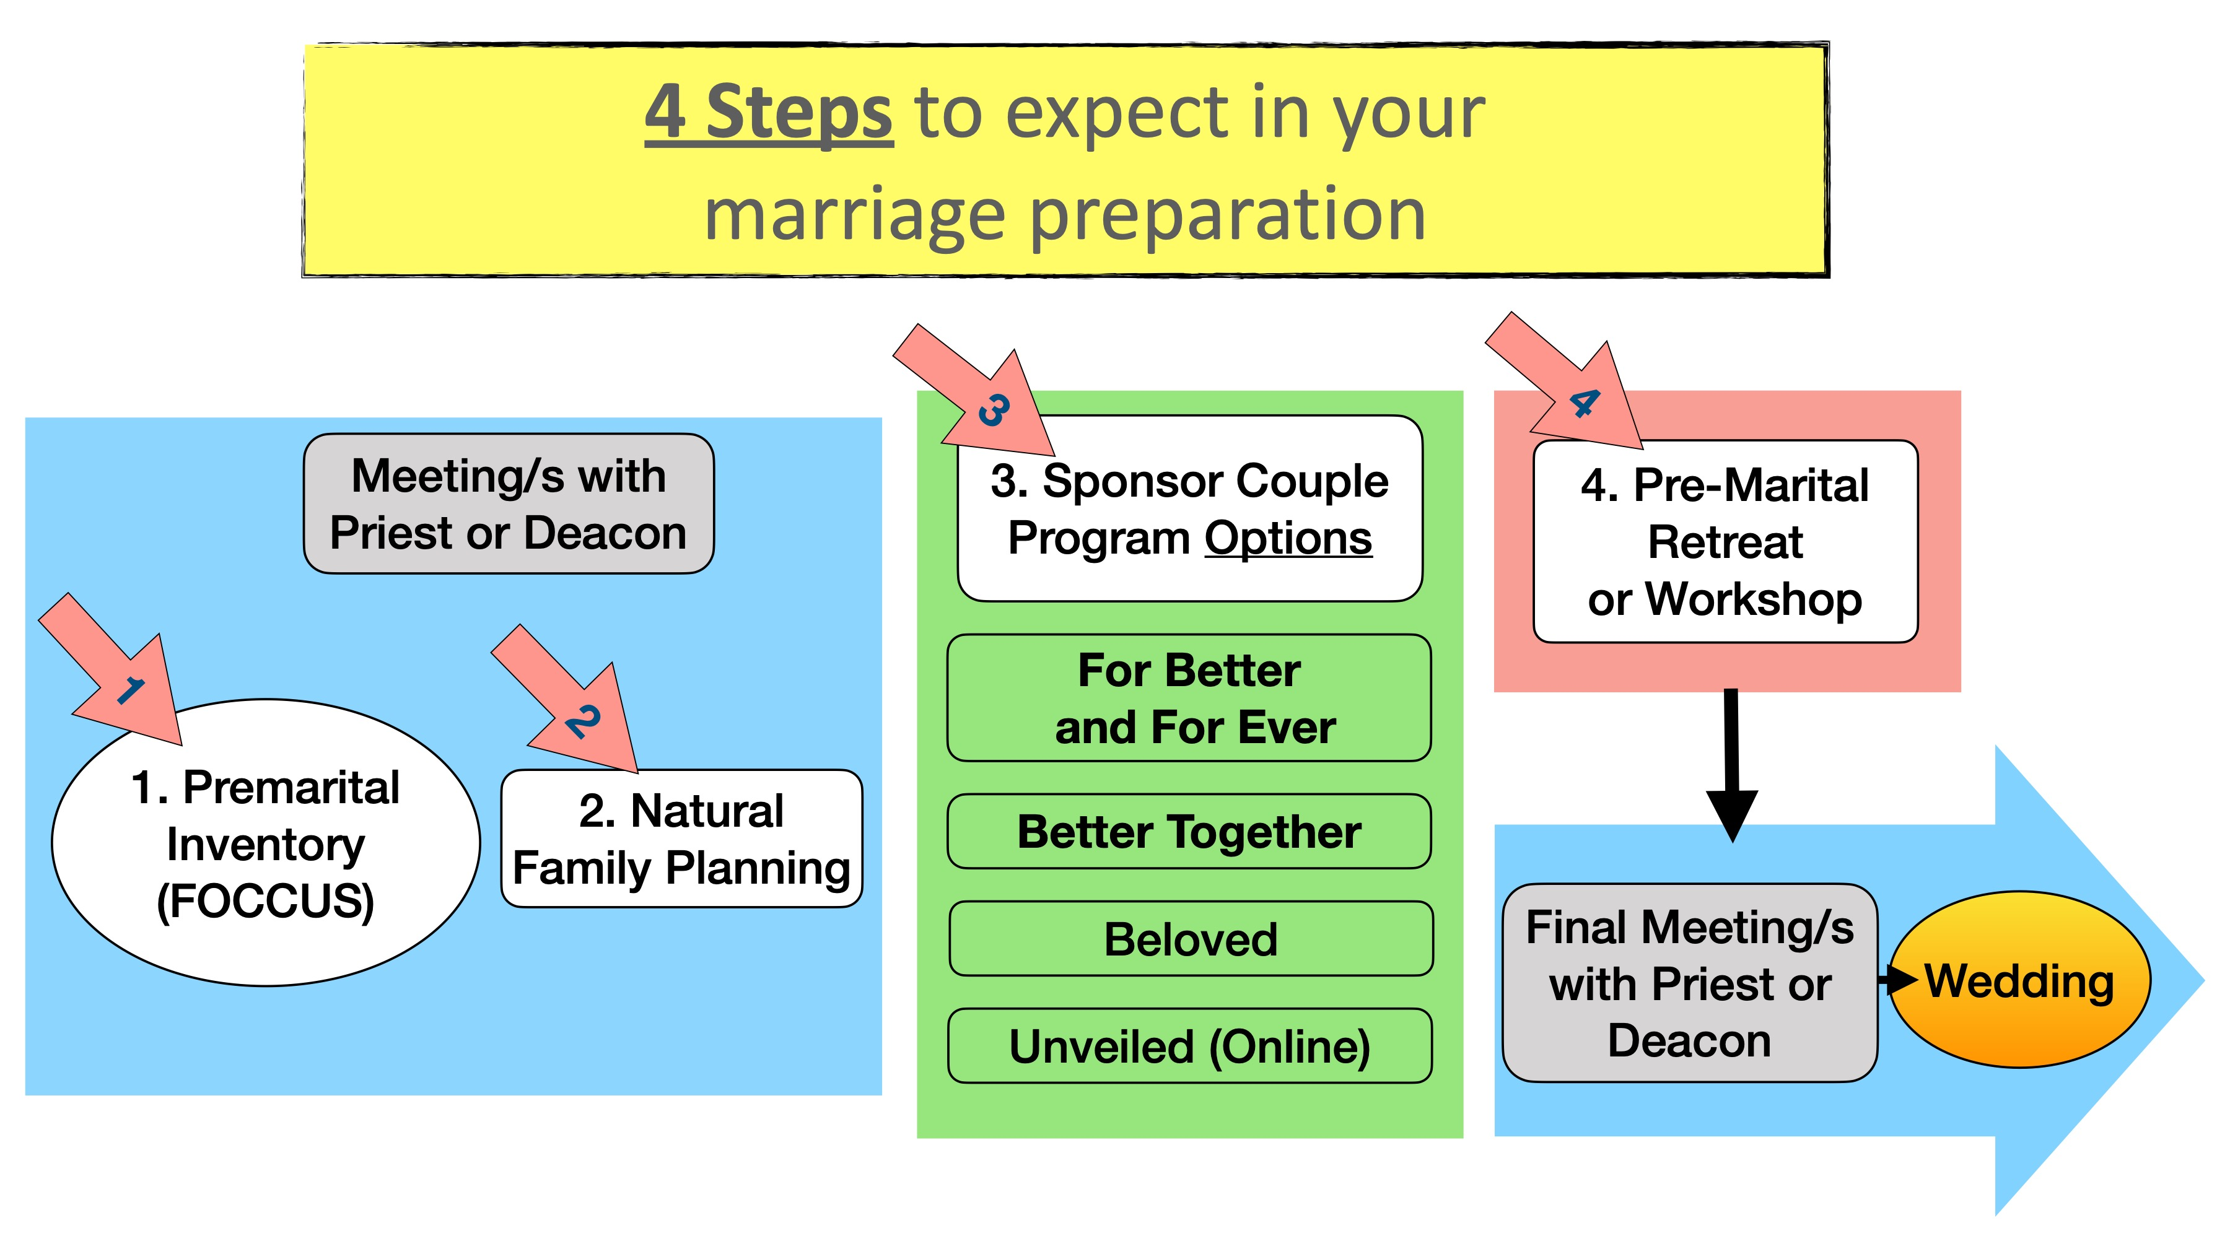

- Second Meeting: After greetings and light discussion:

  - Review the results of their FOCCUS Assessment. This can take from 1 to 3 hours depending on the answers to their assessment questions and how well the couple communicates with each other. You may have to set up an additional meeting or two.
  - Select one of the three NFP Methods discussed in your first meeting. Then call one of the Certified NFP Trainers for that method and exchange contact information with the couple so they can get together. Trainers are listed on page 7 of the “Training Guide” and on the Diocesan web site at https://www.biloxidiocese.org/nfp-instructors Remember that NFP training will take 2 to 3 months of charting the fiancée’s menstrual cycle to gain confidence in knowing when she is fertile and when she is not. Remind the engaged that this training is for the “couple,” not just the female.
  - Sponsor Couple Training: The Diocese of Biloxi has 4 options for sponsor Couple Training. Most Parishes have selected their favorite and use it for their couples. Each parish is responsible for selecting “Sponsor Couples” and having them trained. If you need a sponsor couple training please contact your deanery training rep. Each deanery has 2 deacons assigned to this task.
    - The 4 Sponsor Couple Programs are:
      - For Better& For Ever, A Resource for Couples Preparing for Christian Marriage
        - In using For Better & For Ever, sponsor couples are trained to meet the engaged “where they are” as the starting point for dialogue about the vocation of Matrimony. The Sponsor Couple hosts a series of meetings with the engaged couple in their own home, then after the wedding they follow up with the newly married couple through the first year(s) of marriage. For Better & For Ever is available in English, Spanish, Vietnamese, and French. Program Information: Contact: rob@marriagepreparation.com, 210-534-1129. Website: https://marriagepreparation.com/
      - Better Together
- Better Together is a video-based sponsor couple program consisting of 12 components administered in 6 sessions. Each session uses 4 or 5 short (3 to 6 minute) videos to lead the conversation which is guided by the sponsor couple. The engaged couple uses a workbook that has 2 pages of reading for each video short with a place to take notes. In addition the Leader’s Guide has helpful tips to bring up when discussing each video.
- Better Together includes a Premarital Inventory which can be utilized in addition to FOCCUS if desired. Program Information: Contact: Dynamic Catholic, 5081 Olympic Blvd. Erlanger, KY 41018. Website: https://dynamiccatholic.com/better-together

      - Beloved, Finding Happiness in Marriage.
- Currently 2 parishes use Beloved; St Alphonsus, Ocean Springs and Sacred Heart, Pascagoula. Program Information: Websites: Augustineinstitute.org and Lighthousecatholicmedia.org, run by Augustine Institute under FORMED. Format: Videos and Guide, may be led by local Sponsor Couple. Videos can be streamed online on FORMED.org.

      - Unveiled: Marriage Prep Anytime, Anywhere.
- When an engaged couple is separated by distance Unveiled is recommended. Long distance preparation, though not ideal, is sometimes necessary due to military service or other factors. Military or college chaplains can often provide independent preparation but the presiding minister needs to coordinate the process. Separation is a challenge but not a reason to omit marriage preparation programs.
- Program Information: Online e-learning and DVD; Websites: Unveiledmarriage.com and cdremfl.org; Email: marriage prep@ richmonddiocese.org; Diocese of Richmond VA USA; Format: Videos and Guide, self-led, with online assist.

- Third Meeting: After the couple has completed NFP and Sponsor Couple segments of marriage prep it is recommended that they attend a weekend “Engaged Encounter” retreat. Note: it is recommended that the retreat be scheduled early in the marriage preparation process as weekends fill up and individual schedules may be difficult to work around. The Engaged Encounter Weekend retreats are offered in the three surrounding dioceses (New Orleans, Mobile and Jackson). You need to provide your couple with contact information and options for their retreat. Contact information is on the diocesan web site at:
https://d2y1pz2y630308.cloudfront.net/2647/documents/2020/2/Weekend%20Retreats.pdf

- Final Meeting: After completing the 4 basic steps in the Marriage Prep Roadmap it’s time for a final meeting to make sure all sacramental documentation (Baptismal, Confirmation, Eucharist certificates) and legal documentation (wedding license) are in order. From here one moves to the Rehearsal usually followed by the Wedding the following day.

